1. An industrial machine has sensors placed at 4 different locations. If one of the following conditions arises the machine has to be stopped and should fire an alarm.

* If sensor 1 and 2 are activated
* If sensor 1 and 4 are activated
* If sensor 2, 3, and 4 are activated

Draw a truth table for the above machine and derive a boolean expression.

1. What is the result of adding the following two numbers?

0 + 0 = …

0 + 1 = …

1 + 0 = …

1 + 1 = … and to ...

1. Fill the following table

| A | B | SUM | CARY |
| --- | --- | --- | --- |
| 0 | 0 | … | … |
| 1 | 0 | … | … |
| 0 | 1 | … | … |
| 1 | 1 | … | … |

1. Represent the sum and the carry-out put using two input logic gates in the following block diagram.

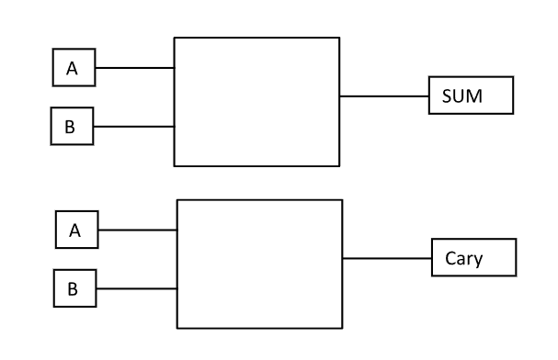

1. Using the above logic gates, design a Half Adder logic circuit.

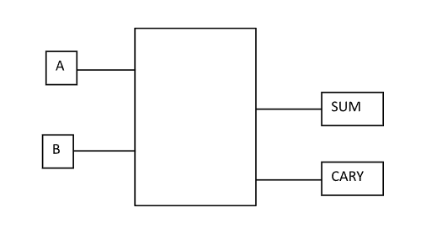

1. Using the above Half Adder circuit design the full adder logic circuit in the following block diagram.

